*Term Project*

*Instructor: Faisal Khan*

|  |  |  |
| --- | --- | --- |
| *Name* | *Student ID* | *Group#* |
| Neelesh Maharjan | C0838743 |  |
| Anila Sunny | C0842969 |  |
| Anupriya Haridas | C0860514 |  |
| Abhishek Arora | C0837189 |  |
| Arman Rohaj | C0860916 |  |

1-Use Documentation Comments where needed and use Javadoc to create HTML files for documentation.

2-In your project src folder add this word document with all your group members names and paste the screen shots of your output after each question.

3-Right Click on your Project Folder in Eclipse, Copy Option is available. Create a copy of the Project and upload the zipped folder using Moodle.

Create a web based application using Either JSF or JSPs & Servlets . Your web application should maintain

Bank Account Records. You can use a model class BankAccount

with fields like.

Account ID, Account Type(Checking/Saving), AccouHolderName,

AccountHolderContact, AccountBalance,AccountSetupDate.

You should be able to perform all these CRUD Operations.

a)Create a Database BankAccounts for your application.

Create a table named Accounts in this database.

Insert 5 to 6 Records in this table. 10

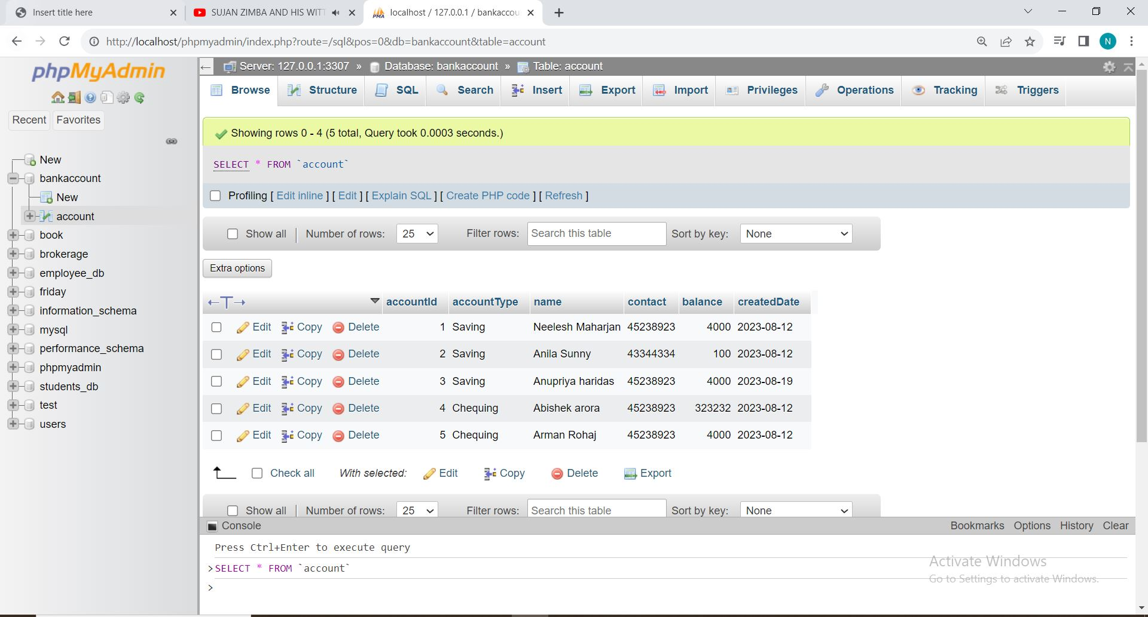

b) Display all the Bank Accounts in your xhtml page View or a JSP page as a table. 20

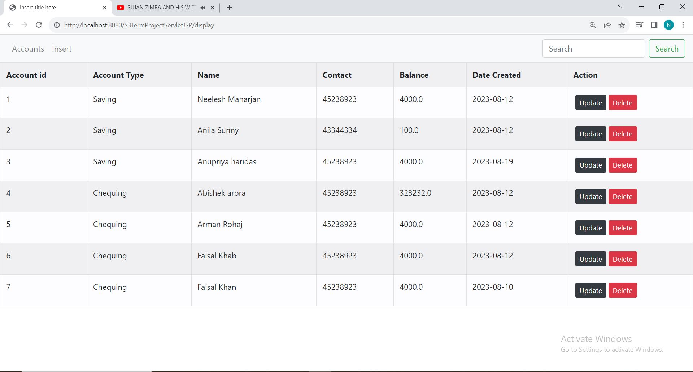

c) Add a new Bank Account in to the database using a button on your view page. 20

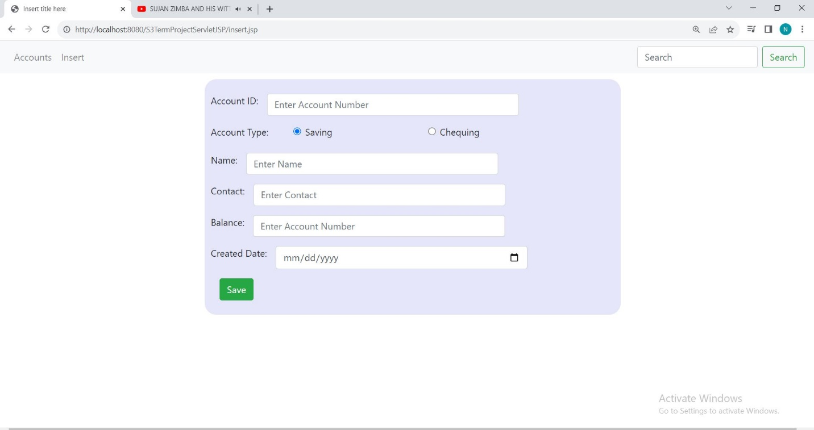

d)Update an existing Bank Account using an Update link on your view page. 20

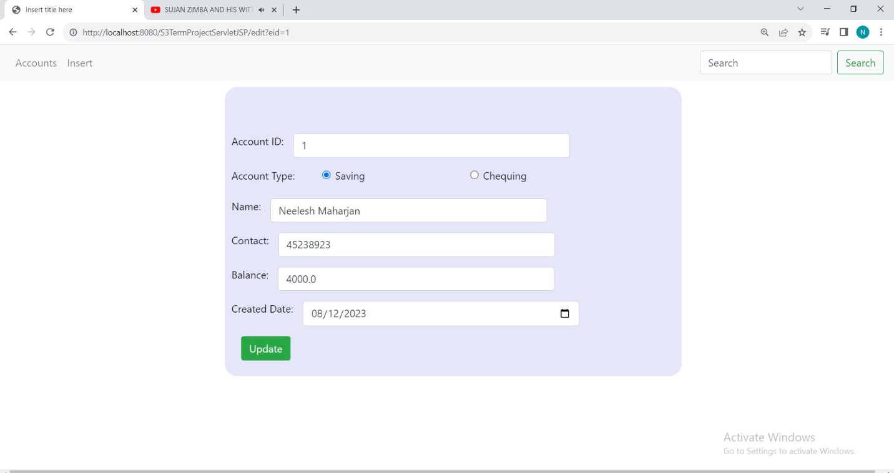

e)Delete a Bank Account using a Delete Link on your view page. 20

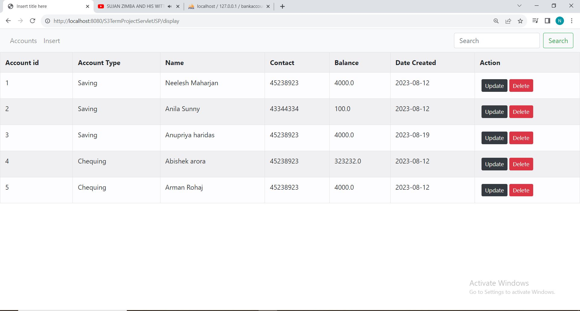

f) Use ManagedBean if using JSF with annotation and create separate DAO class for Crud operations or use a Simple Java Bean as your Model class if using JSPs and Servlets.Try to create separate methods for all crud operations. 10

